# Getting ready

Most of the copy commands are Linux based (run them inside the vagrant Virtualbox VM created during the previous workshop). For Windows (where the locations of your files might differ) you need to manually copy them or use copy commands instead of cp and update the path

## Check prerequisites

### Is the VM running

Below is a description for Virtualbox/Vagrant. For the Windows installation check the Hyper-V manager for the minikube container.

Check Virtualbox to make sure the VM is running

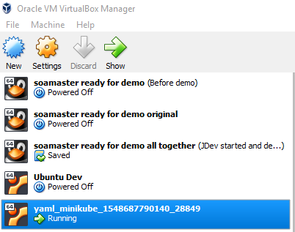

Do in the directory where Vagrantfile is located the following:

vagrant ssh

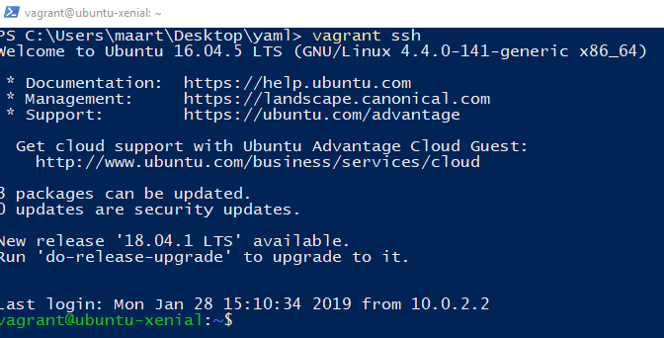

If you have not done so earlier, install a JDK and Maven so you can build the whiskeyshop inside the VM (if you want to)

sudo apt-get install maven default-jdk

### Is minikube running

Check if mimikube is running by opening a browser and going to <http://127.0.0.1:8001/api/v1/namespaces/kube-system/services/http:kubernetes-dashboard:/proxy/#!/deployment?namespace=nl-amis-development>

If minikube is not running, you can start it with:

sudo minikube start --vm-driver none

sudo cp /etc/kubernetes/admin.conf $HOME

sudo chown $(id -u):$(id -g) $HOME/admin.conf

export KUBECONFIG=$HOME/admin.conf

kubectl proxy --address='0.0.0.0' --port=8001

## Install required sources

Prepare the whiskeyshop Docker container. For the Vagrant VM do:

cd ~

git clone <https://github.com/AMIS-Services/sig-springboot-1.git>

cat > sig-springboot-1/lab7-docker/whiskeyshop/ src/main/resources/application-mysql.properties <<EOL

spring.datasource.url=jdbc:mysql://localhost:3306/test?allowPublicKeyRetrieval=true&useSSL=false

spring.datasource.username=root

spring.datasource.password=password

spring.jpa.database-platform=org.hibernate.dialect.MySQL5InnoDBDialect

spring.jpa.hibernate.ddl-auto=create

EOL

cd sig-springboot-1/lab7-docker/whiskeyshop

mvn clean package

docker build -t whiskeyshop:v1.0 .

For Windows use your favourite git client or Download git for Windows (https://git-scm.com/download/win) if you haven’t installed it yet.

Clone the repository to the location you want (go to a folder and give git clone <https://github.com/AMIS-Services/sig-springboot-1.git>). Next replace src/main/resources/application-mysql.properties with

spring.datasource.url=jdbc:mysql://localhost:3306/test?allowPublicKeyRetrieval=true&useSSL=false

spring.datasource.username=root

spring.datasource.password=password

spring.jpa.database-platform=org.hibernate.dialect.MySQL5InnoDBDialect

spring.jpa.hibernate.ddl-auto=create

Download the Kubernetes yaml files

git clone https://github.com/AMIS-Services/sig-kubernetes.git

# Getting started with Helm

Note: if you get issues like;



First do

sudo cp /etc/kubernetes/admin.conf $HOME

sudo chown $(id -u):$(id -g) $HOME/admin.conf

export KUBECONFIG=$HOME/admin.conf

## Install helm

Vagrant VM (when inside with vagrant ssh)

sudo snap install helm –classic

Windows (when Chocolatey is installed).

choco install helm

## Install tiller

helm init

Confirm from the Kubernetes dashboard tiller has been installed (kube-system namespace under deployments)

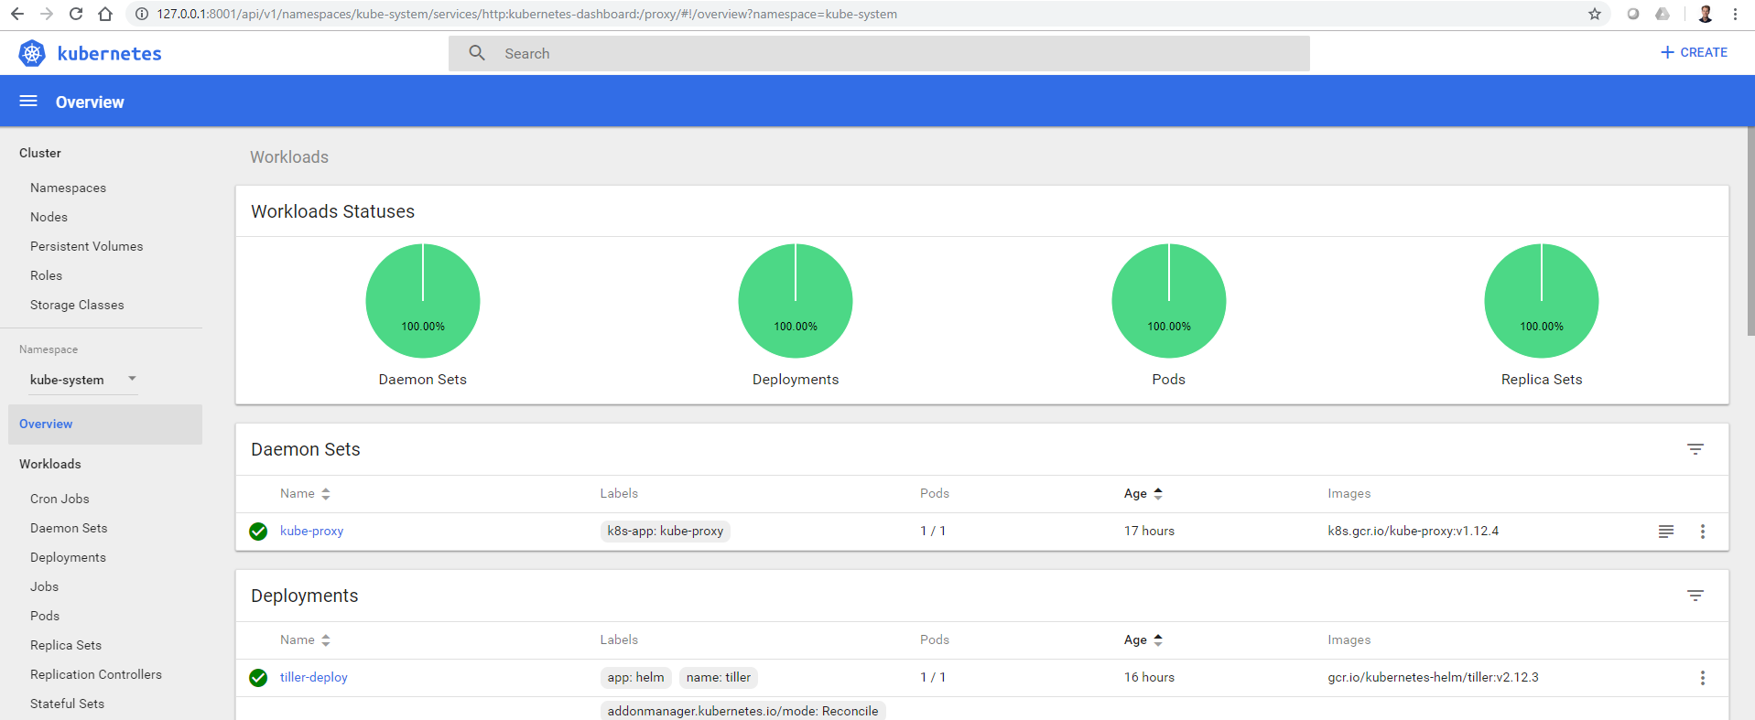

## Create a new helm chart

cd ~

helm create whiskeyshop-chart

Examine the directory structure

Copy the whiskeyshop yaml files to the helm template folder

rm -rf /home/vagrant/whiskeyshop-chart/templates/*

cp ~/sig-kubernetes/SIG01/lab02-kubernetes/Lab02-kubernetes-whiskeyshop-mysql/env/yaml/* /home/vagrant/whiskeyshop-chart/templates

Update deployment-whiskeyshop.yaml to use the hostname instead of IP

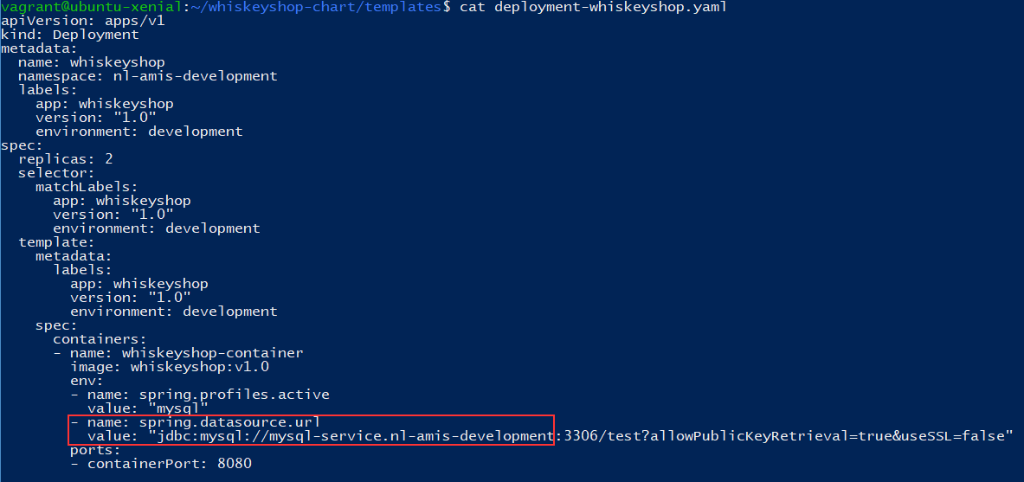

Go to the whiskeyshop-chart folder

Validate the chart

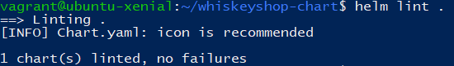

Install the chart

helm install .

Error: release pining-ant failed: namespaces "nl-amis-development" already exists

Parts of the release are already installed. First remove them by using the Kubernetes dashboard or kubectl delete commands while in the directory with the yaml files.

Windows or Vagrant VM

kubectl delete -f service-mysql.yaml

kubectl delete -f service-whiskeyshop.yaml

kubectl delete -f deployment-mysql.yaml

kubectl delete -f deployment-whiskeyshop.yaml

kubectl delete -f persistent-volume-claim-mysql.yaml

kubectl delete -f persistent-volume-mysql.yaml

kubectl delete -f namespace-production.yaml

kubectl delete -f namespace-development.yaml

Vagrant VM

find . -name "*.yaml" -exec kubectl delete -f {} \;

After cleaning up first do a dry run:

helm install --dry-run --debug .

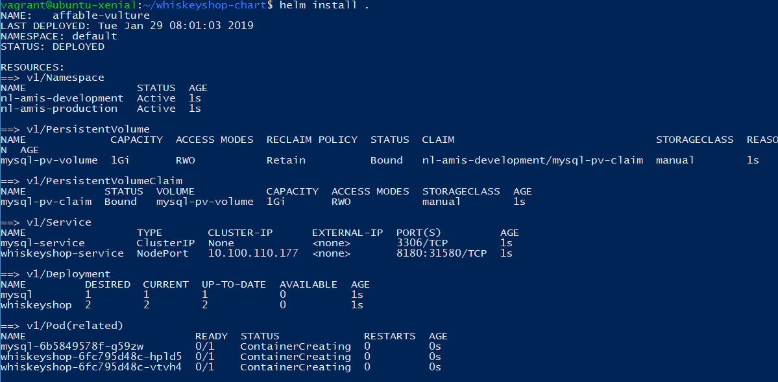

Go to the Kubernetes dashboard at <http://127.0.0.1:8001/api/v1/namespaces/kube-system/services/http:kubernetes-dashboard:/proxy/#!/deployment?namespace=nl-amis-development> and verify everything is there and running without errors.

Check that the release is deployed

helm ls



In my case, the release is named affable-vulture. This is a generated name and not a good name for a release.

Undeploy the release

helm delete affable-vulture

Redeploy the release with a name

helm install . –name whiskeyshop-release

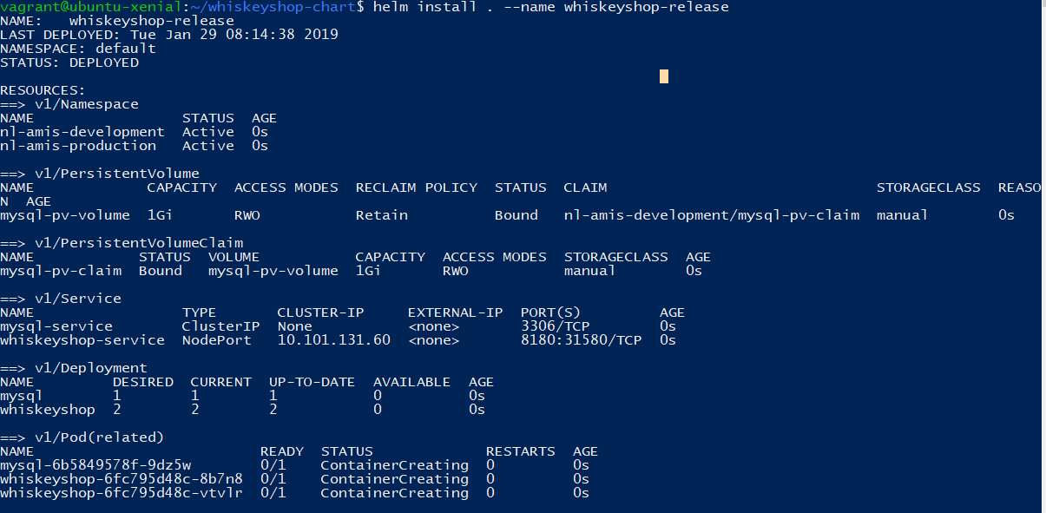

Update the version of the release in Chart.yaml to 0.2.0

Upgrade the release

